Parth Babbar

Customer relation management

**Introduction:**

Customer Relationship Management (CRM) is a strategic and technological framework used by banks to manage and analyse customer interactions and data across the entire customer lifecycle. CRM systems strive to improve profitability and expedite processes by integrating customer data, automating marketing, sales, and customer support tasks, and giving actionable insights. CRM's major purpose is to strengthen customer service interactions, promote client retention, and drive sales growth.

**Importance of CRM:**

1. **Enhanced Customer Service:** Banks use CRM systems to provide effective customer service by keeping client information accessible and recording interactions. This enables personalised services and prompt issue resolution, increasing client happiness and loyalty.
2. **Boost Customer Retention:** Understanding client requirements and preferences allows banks to personalise their goods and services, resulting in increased customer satisfaction and loyalty via specialised products and proactive involvement.
3. **Drive Sales Growth:** CRM solutions assist banks in identifying prospective sales and cross-selling/up-selling possibilities, which leads to increased customer satisfaction and loyalty through specialised products and proactive involvement.
4. **Operational Efficiency:** CRM technologies improve operational efficiency by automating regular processes and connecting client data throughout departments. This simplifies procedures and facilitates the identification of prospective sales opportunities, as well as the cross-selling and up-selling of bank goods and services, resulting in increased client satisfaction and loyalty through specialised products and proactive involvement.

**Key Components:**

1. **Customer Data Management:** Customer Data Management (CDM) in CRM systems gathers and centralises information from several touchpoints to generate a single customer view. Ensuring data accuracy and utilising analytics enhances decision-making and customer service. CRM systems automate mundane operations and integrate data across departments to expedite procedures, find sales possibilities, and enable cross-selling and upselling. This results in increased client satisfaction and loyalty through targeted offerings and proactive interaction.
2. **Customer Interaction Management:** CRM systems enable consistent service across many channels (email, phone, social media, and in-person) and give a unified omnichannel experience. They enable multi-channel interaction, personalise messages based on customer profiles, manage marketing campaigns targeted at certain segments, and gather and act on customer feedback to enhance service.
3. **Personalization:** CRM systems provide for customised banking goods and services based on individual client needs, preferences, and financial behaviours. They employ AI and machine learning recommendation engines to promote items or services based on bank transactions. CRM systems also use behavioural targeting to send personalised marketing messages and offers based on customer behaviour and interactions.  
   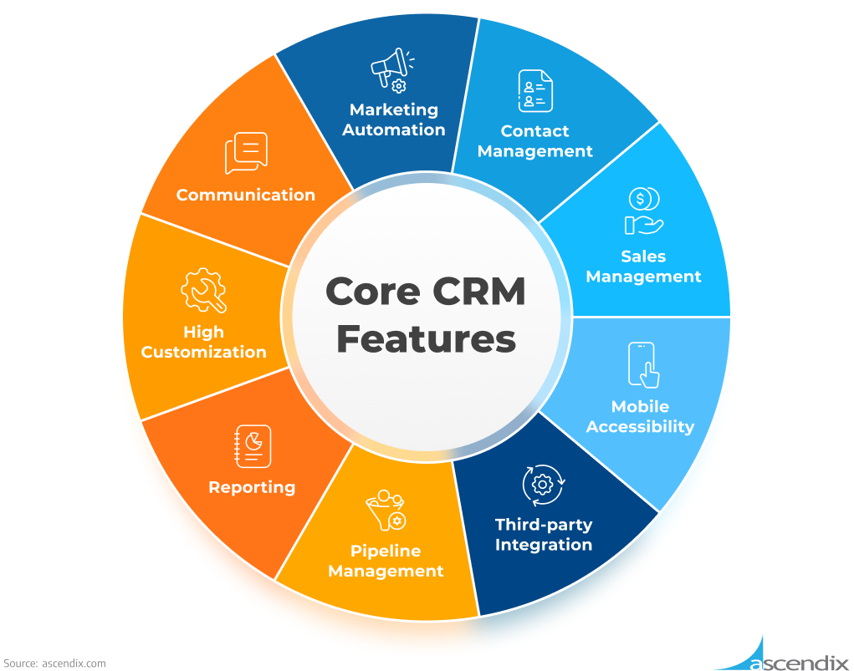

**CRM Technologies Used:**

1. **Data Analytics:** Advanced data analytics enables banks to better understand client behaviour and preferences.
2. **Artificial Intelligence (AI) and Machine Learning (ML):** Chatbots and virtual assistants employ AI and ML to forecast client demands, identify fraud, and provide automated customer support.
3. **Customer Data Platforms (CDPs):** CDPs combine customer data from several sources to provide a unified customer perspective.
4. **Consumer Engagement Platforms:** These platforms handle consumer interactions across several channels (email, social media, phone, in-branch).
5. **Mobile and Online Banking Apps:** Better user interfaces and personalised features increase the consumer experience.

**Risk:**

1. **Data Privacy and Security:** Keeping customer data safe from breaches and maintaining compliance with privacy laws.
2. **Integration Issues:** Integrating CRM systems with current financial systems and data sources.
3. **Customer Trust:** Ensure that CRM activities are not perceived as invasive or exploitative.
4. **Cost Management:** Balancing the costs of establishing and maintaining CRM systems against the anticipated benefits.

**Case Studies and Statistics on CRM in Banking:**

**Case Studies:**

1. **Bank of America(2018):** Implemented AI-driven CRM solutions, leading to a 15% boost in customer satisfaction levels.
2. **Chase Bank(2019):** Used CRM to improve the mobile banking experience, which resulted in a 20% increase in mobile banking users.

**Statistics:**

1. **Customer Satisfaction:** Banks with efficient CRM systems have up to 74% greater customer satisfaction rates.
2. **Revenue Growth:** Banks that use advanced CRM solutions claim up to 20% revenue growth from existing clients.
3. **Customer Retention:** CRM tactics may increase customer retention rates by up to 27%.
4. **Cost Savings:** According to the Aberdeen Group, banks who utilise CRM can save up to 23% on operating costs.

**Conclusion:**

CRM is critical for US banks to remain competitive in a continuously changing financial environment. Banks that engage in modern CRM systems and tactics may greatly enhance customer service, retention, and sales while also increasing operational efficiency. The example of Wells Fargo highlights the practical benefits of a strong CRM system in driving corporate development and improving customer experience.